HW 5
Question 1
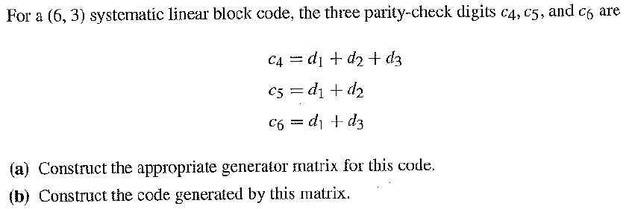
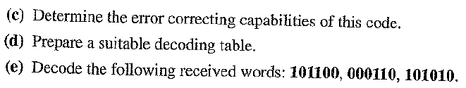
Question 2
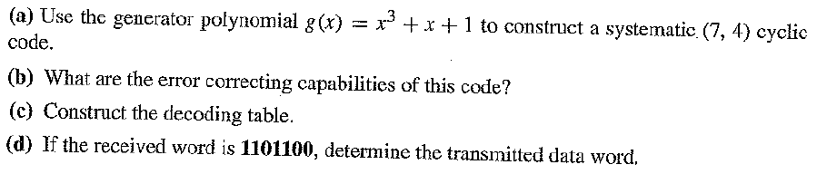
Question 3
